Tab 1

Volatility Research for AA smallcases

HAR-RS model:

This report summarises the modelling and analytical framework employed for analysing weekly realised downside volatility (DRV/RS) and related features. The study focuses on modelling realised volatility using Hetero autoregressive and realised semivariance approaches, inspired by HAR-RV frameworks. The goal is to forecast short-term volatility behaviour using lagged realised measures and other explanatory variables derived from historical price data, and then generate signals suitable for AA models based on predicted Volatility.

Data Discussion:
We use weekly OHLC data from the Nifty 50 index and derive features from this dataset. We extend the baseline model by introducing True range features. Variables used in this study are:
- Y variable: Realised Semi-Variance, i.e. negative returns squared
- X variables: Lagged (1 week, 1 month and 1 quarter RS) + Lagged (TR, 1 Month ATR and 1 quarter ATR)

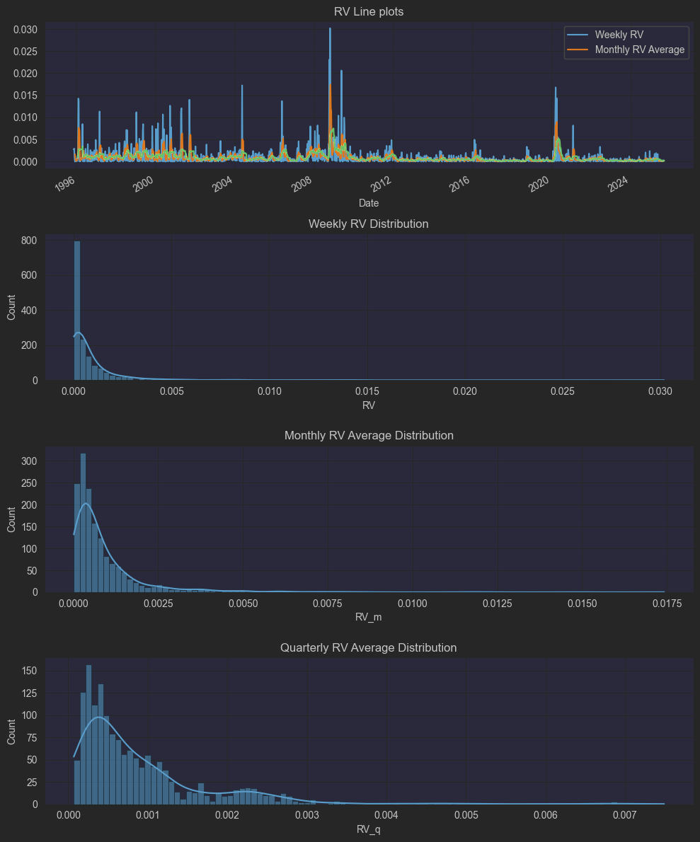
Figure 1: Lineplot and Distribution of RS variables
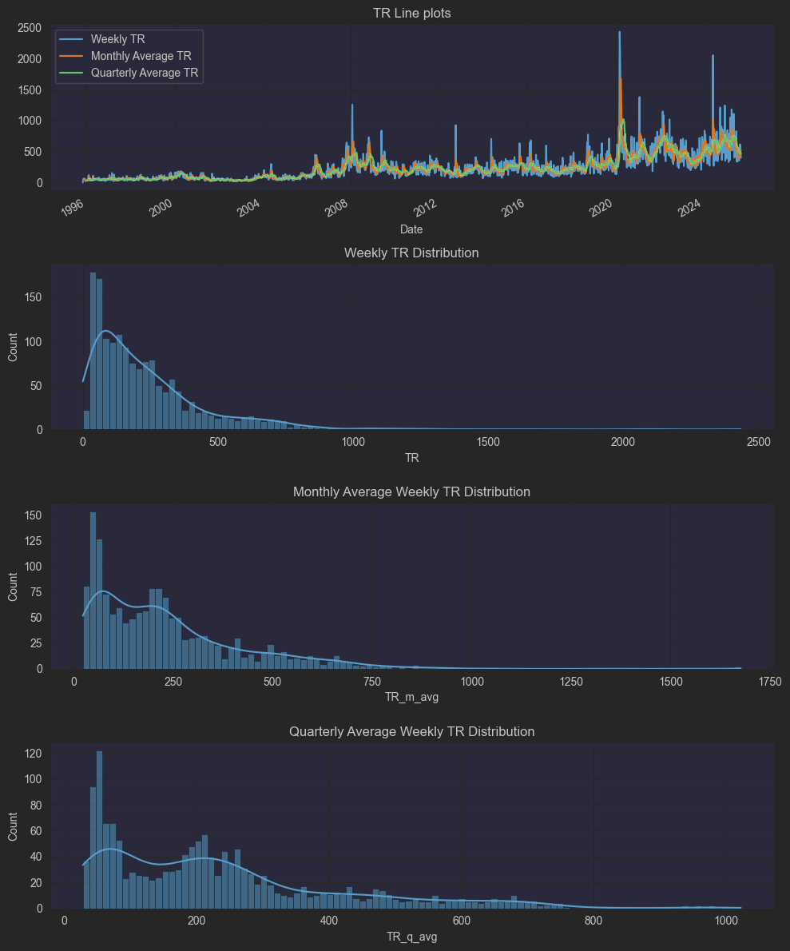
Figure 2: Lineplot and Distribution of ATR variables

From the above figures, we can see that we need to normalise the dataset before we start implementing our model. Thus, for this study, we are using a rolling 6-month z-normalisation method.

Model Implementation:

${{RS}^{w}}_{t+1w}= c+β^{w}R{S^{w}}_{t}+β^{m}{R{S^{m}}_{t}+{β_{}}^{q}R{S^{q}}_{t}+u_{t}}_{}$
Where:
- RS: realised semi-variance
- $R{S^{d}}_{t}$: 1 week RS
- ${{RS}^{w}}_{t}$: Monthly RS (mean of last week 1 1-day RS)
- ${{RS}^{m}}_{t}:$ Quarterly RS (mean of the last 21-day RS)
- Target: 1 week Forward RS

Training Period: 1996-07-19 to 2019-12-27
Testing Period: 2020-01-03 to present

We estimate the model parameters on the training period, and then, using these parameters, we predict RS for the testing period.

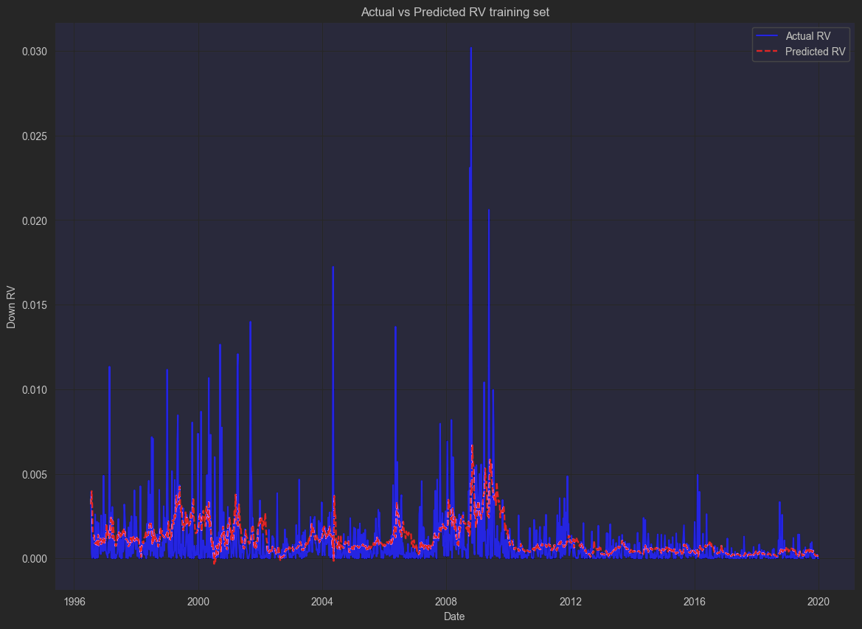
Figure 3: In-Sample Prediction comparison

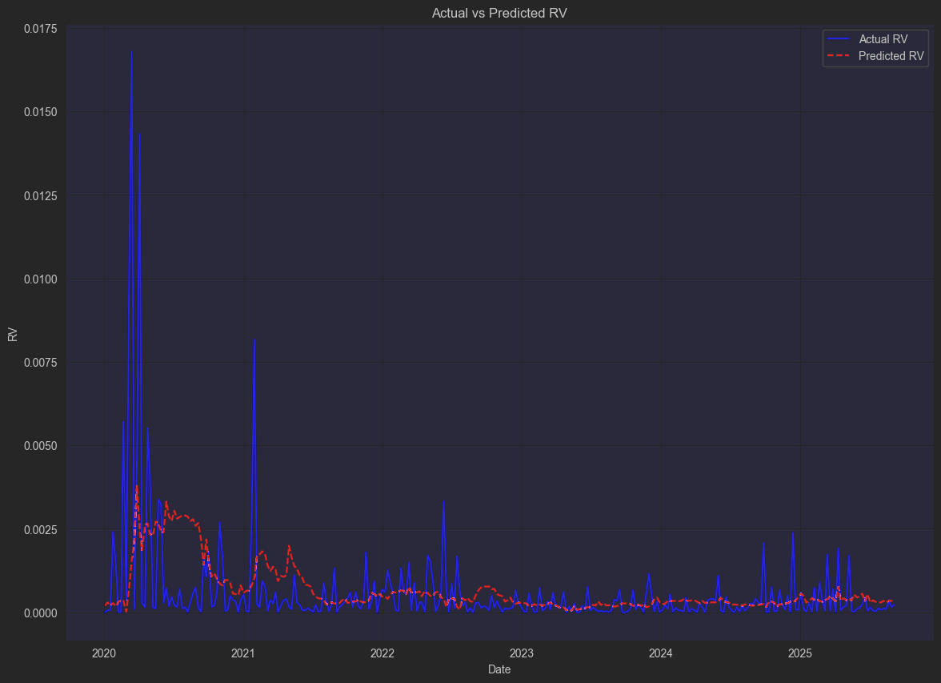
Figure 4: Out-of-Sample Prediction comparison
Walk-forward test observations: 297
RMSE (raw RS): 0.001599
MAE (raw RS): 0.000720

Next, we bucket these predicted RS based on 30 quantile boxes. Based on these quantiles, we compute the mean of each bucket and then compare the predicted RS to the mean bucket to check if our prediction over- or underpredicts the downside vol. We generate signals based on the rule that if the predicted RS belongs in a bucket <= 30th percentile, we want to be in equity; if the predicted vol is greater than the 30th percentile bucket, we want to switch to gold.

Results:

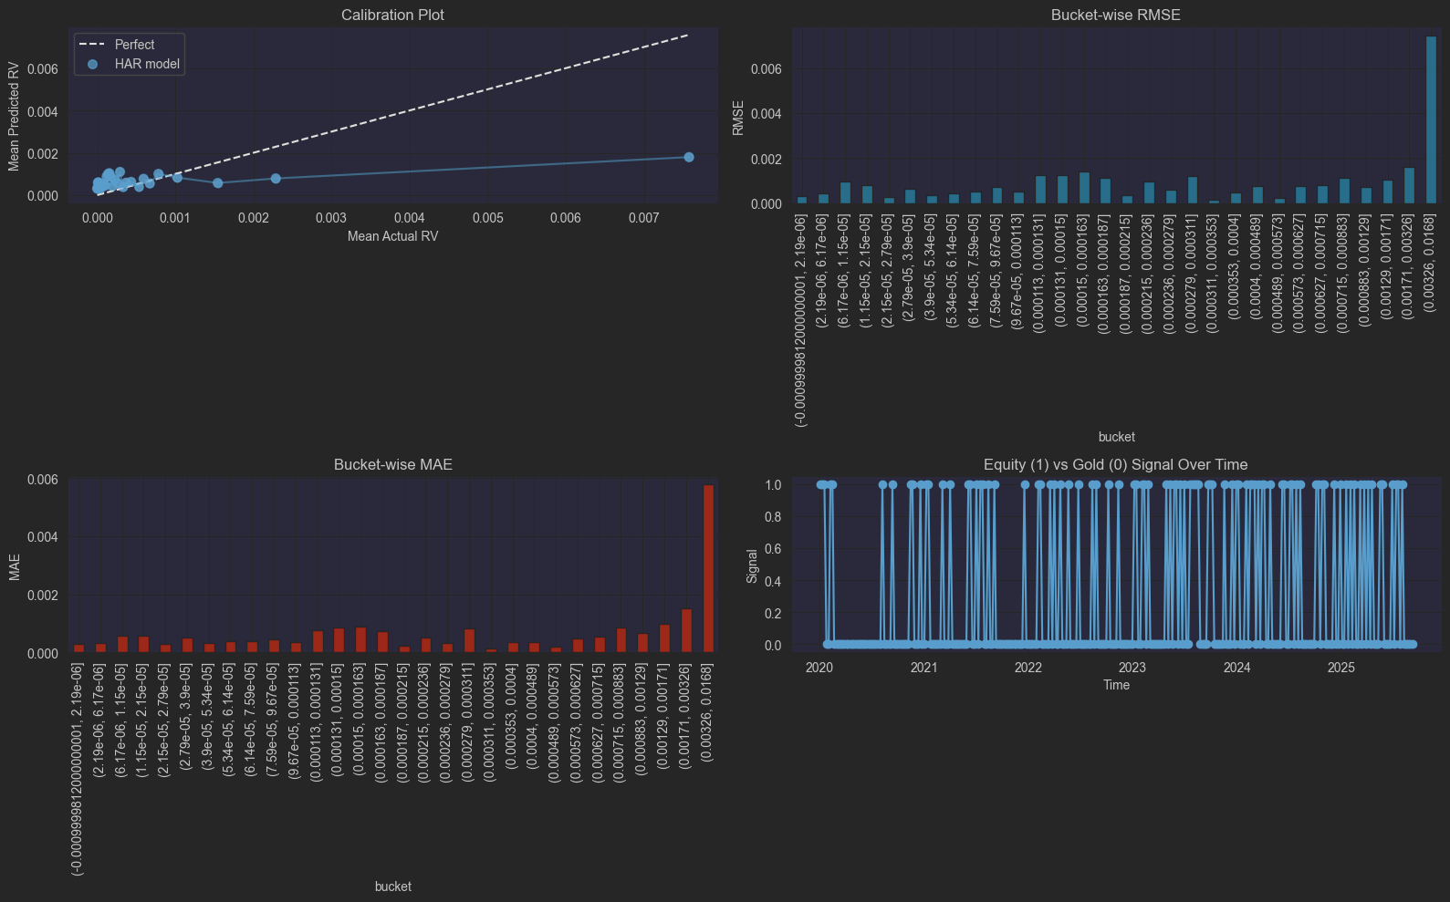
Figure 5: Results plot from the model implementation.

- From the calibration plot, we can see that our model performs well in low and normal volatility regimes, but under-predicts high volatility regimes.
- The signal generated based on our rule gives us a realistic performance and effectively captures volatility changes.

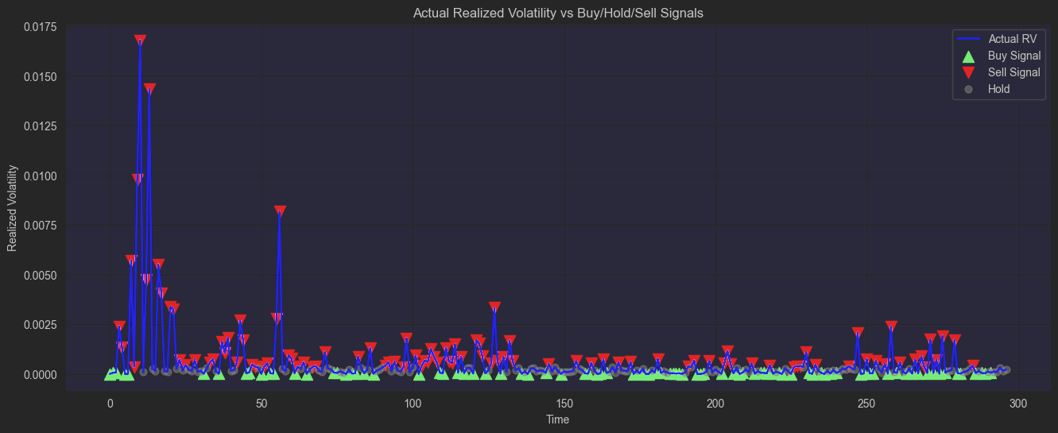

Challenges and Future Improvement:

- Given that this model is made for high-frequency data, our implementation on a weekly frequency dataset gives us a weak R-squared value.
- Signals generated from this model tend to introduce a higher trade turnover, which is not suitable for AA's small cases/assets allocation usage.
- To validate our model further, we should try to implement this model on a cross-sectional level, testing for multiple assets in our stock universe.
- Also, implement a formal benchmarking test to validate how a portfolio using these signals performs.

Motif + PSMC model:

The purpose of this study is to develop a data-driven framework for volatility regime classification and forecasting based on historical motif similarity. The approach leverages Motif Matching (MASS algorithm) and weighted average based on motif distance to predict near-term realised volatility, evaluate predictive performance, and map these predictions into discrete volatility regimes (high, medium, low).

The results aim to provide a systematic basis for detecting volatility regimes, managing risk, and targeting portfolio volatility.

Data Discussion:

Item | Description
Dataset | Historical equity index returns (e.g., NSE Nifty)
Frequency | Daily close-to-close returns
Sample Period | Full history available (filtered for rolling window computations)
Rolling Window | 45-day realised volatility
Forecast Horizon | 1 month (30 trading days)

Our main target variable is realised variance, i.e. return squared.

Model Implementation:

Motif-Based Similarity Search
- A sliding window was used to extract 45-day realised volatility sequences.
- The MASS (Mueen’s Algorithm for Similarity Search) identified historical periods most similar to the latest volatility window.
- Top-N matched motifs formed the analogue ensemble for forecasting.
For each motif, forward realised volatility over the next 30 trading days was computed.
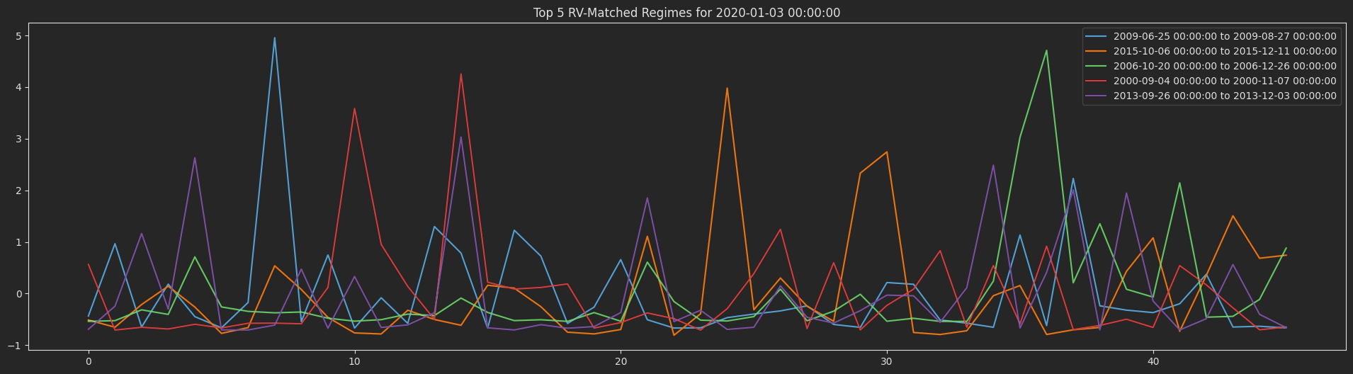
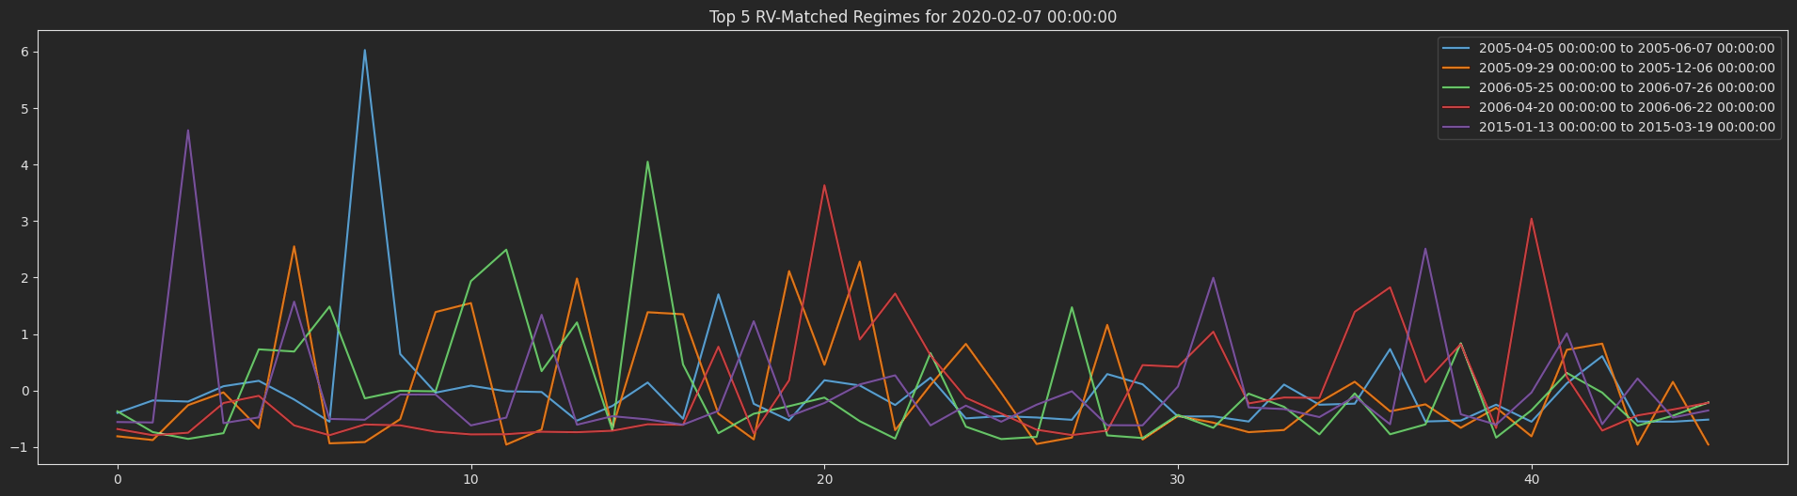
Weighted Forecasts
Two ensemble forecasts were derived:
- Inverse-Distance Weighted (IDW): We use the motif distance to weigh the average 1-month realised volatility for the top 5 motifs
- Nadaraya–Watson (NW) Kernel Regression: Using the method in the PSMC study, we weigh the 1-month realised volatility for the top 5 motifs using this method.

We bucket these predicted RS based on 30 quantile boxes. Based on these quantiles, we compute the mean of each bucket and then compare the predicted RS to the mean bucket to check if our prediction over- or underpredicts the downside vol.

Results:
To validate our prediction, we use the observed 1 month starting from the rebalancing date. This gives us an understanding of the relationship between our prediction and the actualised volatility. We find a weak positive correlation between our prediction and the observed volatility.

Correlation between simple forecast and actual volatility: 0.1143
Correlation between NW forecast and actual volatility: 0.1031

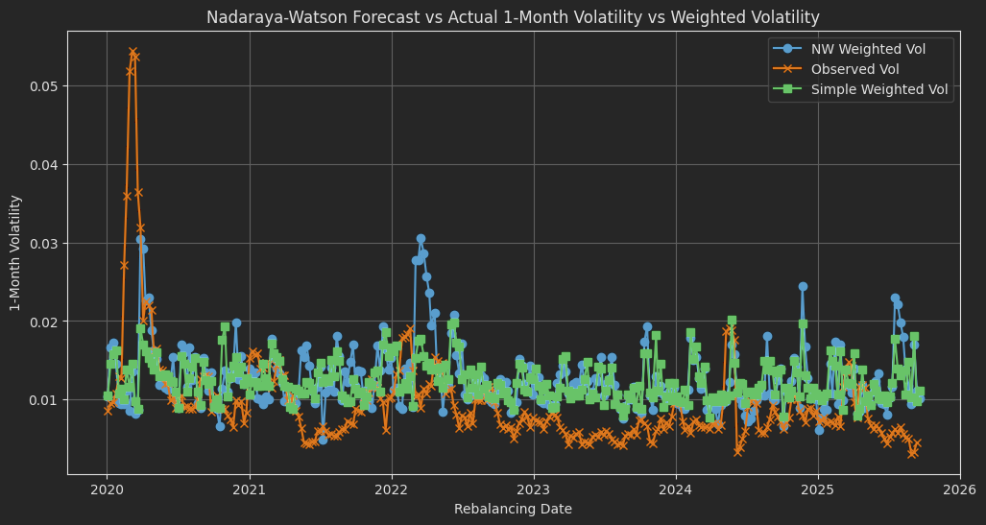

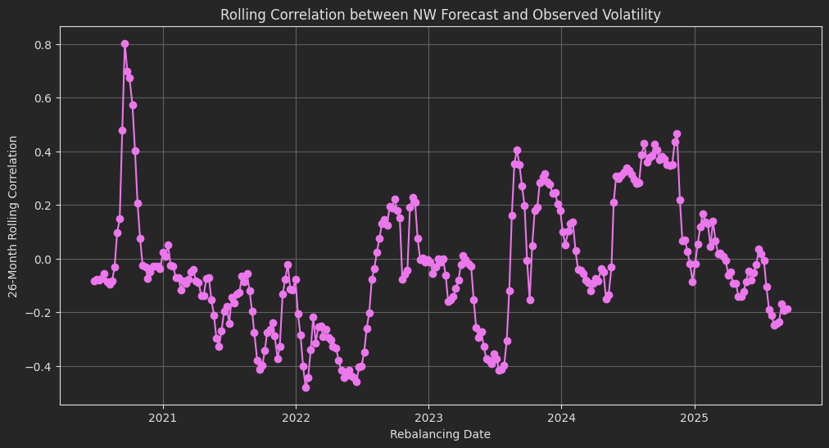

From our bucketing exercise, we further validate this relationship as we see the mean prediction bucket shows a weak linear relationship to the actual observed volatility. We also observe that our prediction performs better for normal volatility regimes. For low volatility regimes, our prediction always has an upward bias and for high volatility regimes, our prediction tends to have a downward bias.

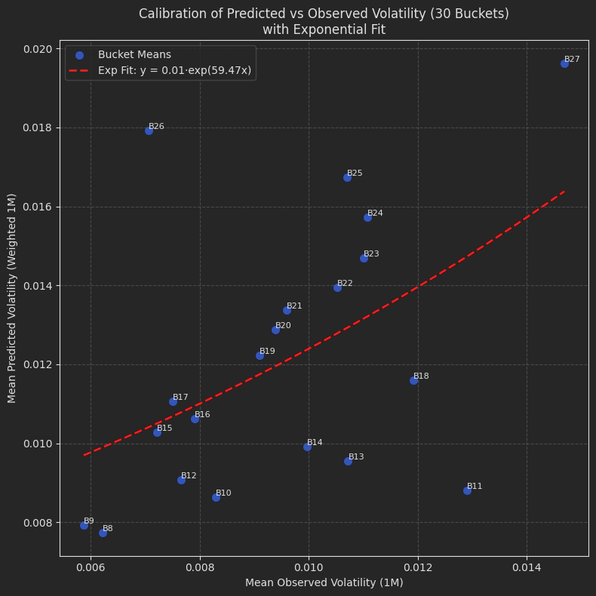

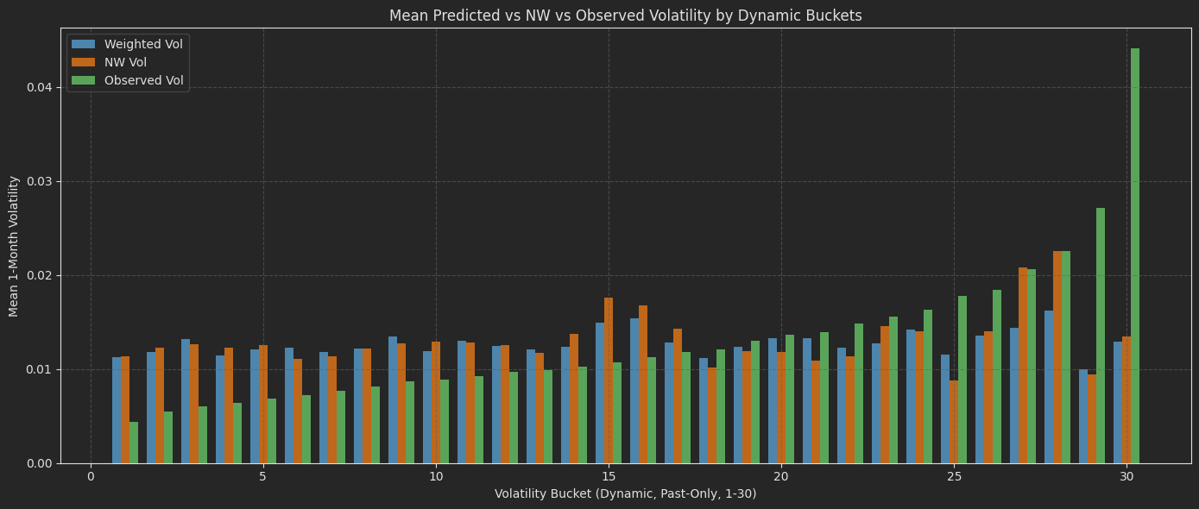

Challenges and Future Improvements:
- A weighted average approach looks simple, and to enhance our model in a similar spirit to the PSMC study, we can use a moment simulation to generate similar RV paths and then compute the weighted average. This might improve our results due to the law of large numbers.
- Signals generated from this model tend to introduce a higher trade turnover, which is not suitable for AA's small cases/assets allocation usage.
- Extend analysis to a cross-asset dataset to further validate our findings.
- Implement a formal benchmarking test to validate the performance of a portfolio using signals from our prediction buckets.

Signal Improvement and Calibration:
Based on the bucketing analysis, we see that the median buckets of prediction vs observed fit on an exponential curve give us the most appropriate prediction buckets that incorporate the non-linear relationship between the prediction and observed volatility. Using this finding, we recalibrate our volatility prediction using an expanding window rule, which avoids any look-ahead bias. We then normalise the signal further using a rolling window, such that the prediction signals reflect the volatility distance scale.

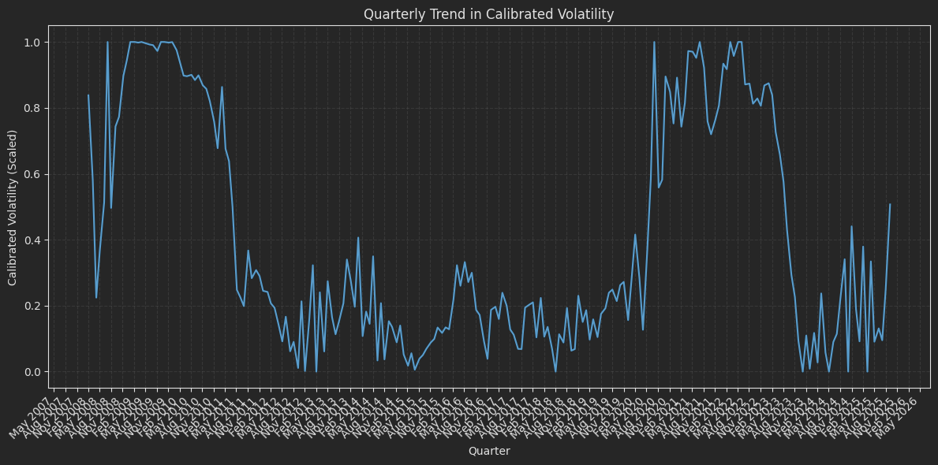

Backtesting Framework:

- We generate a volatility signal every week based on the weighted average of motifs 1 1-month forward volatility. Then we create buckets and recalibrate the bucket based on the best-fitting parameter on an exponential curve, and normalise the recalibrated bucket to get our final signal.
- We create two other variations of the signal based on monthly rolling and an exponential moving average to further smoothen out the signal.
- We rebalance our portfolio at the start of each month and use the signal generated for the rebalancing date to create weights for our portfolio constituents.
- If the signal is <= 0.33, we are in a low volatility regime and give equity .70 weight and gold 0.30 weight. If the signal is > 0.33 & <= 0.67, we are in a medium volatility regime, thus giving equity and gold an equal weightage of 0.50. When the signal > 0.67, we are in a high volatility period, and this gives equity 0.30 weightage and gold .70 weightage.
- To compare our custom portfolio, we use Small Case equity gold (SCET_0005) as our benchmark.
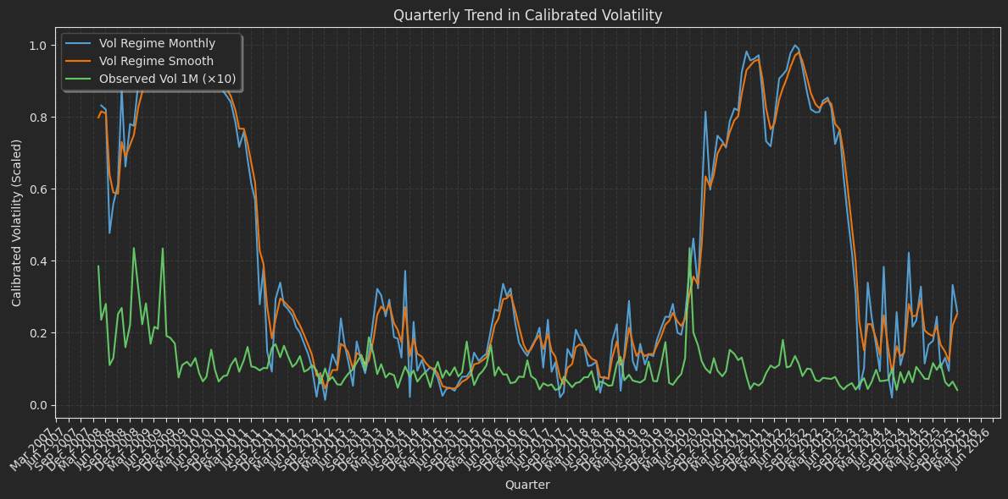

Backtest Result:

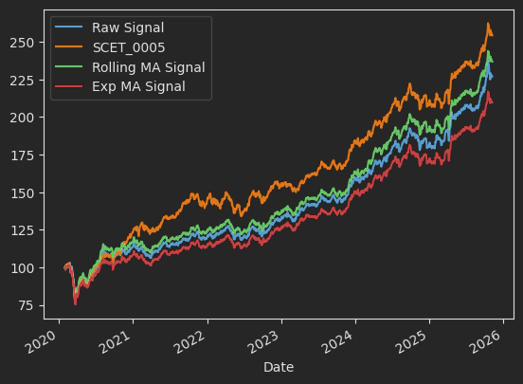

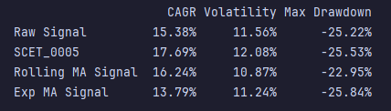

The rolling MA smoothed signal performs the best compared to the raw and exponential MA signals. But our benchmark outperforms all the signals on a return/CAGR basis. But our rolling MA signal gives us a less volatile portfolio in terms of lower standard deviation and drawdowns.

.

Manu’s points:
- We need to model Gold’s time series as well
- Start with basic Super trend calculation for gold (Mauc1)
- Move into the Linear model aspects of the Gold the same way we did for Nifty 50.

To-Do
Macro variables:
- https://docs.google.com/spreadsheets/d/1Mn4Bx5W3c3PP3XwHxjxPdmB3gbla27Yd90TC6IMJb1c/edit?gid=0#gid=0

To Do:
- EDA:
- This would have different sets of graphs and their relationship between different variables.
- Y variable: Drawdown, semi-standard deviation for 3 major indices, returns.
- Y variable: Components of the different sets of the covariance matrix between 3 indices. The diagonals would be individual variances, but the off-diagonal values would be the covariance between the different variables ( major M-cap based indices ). The diagonal elements of the covariance matrix would be the variance of the market cap indices. The objective here would be to gauge the correlation behaviour across different indices in different regimes.
- X variable: scatter plot of the X variable to gauge the relationship. If the correlation is high, then we can think of removing the unimportant variables
- Time series modelling: the scatter plots would be a collective view rather than a time series or event-based view. To remove the bias of certain events, we need to filter out those events differently and see the relationship between X and Y as well as only X. For eg, COVID. How will you filter out those events? Is it going to be a Y variable, percentile-based ( extreme percentiles)? Filter out those points differently. Winsorization, but time series included. For eg, the 95th percentile belongs to a day in the COVID crash, you will take the points around these values. And see the relationship between X variables and Y+X variables. We want to understand how things (all the stats mentioned above) behaved before and after the event.
- Correlation between the X variables themselves.
- Add 1 step forward for Y variables and repeat the same exercise.
- After the EDA, you can have multiple relationships to analyse the choose the correct model from them.

Paper repos:
- What you have shared on Slack: paste the link here:
  - https://www.twosigma.com/articles/a-machine-learning-approach-to-regime-modeling/
  - https://www.kaggle.com/code/selcukcan/ml-5a-market-regimes-prediction-using-clustering
- Autoencoder paper
- I have to share the blog and paper link shared by JD.

Daily Time series with PE, PB, Div Yield:
Paste the sheet link here

Market cap-based:

Index | Start Date | End Date | Valid Observations | Total Rows | Comments | Group
Nifty 500 | 1996-01-01 | 2025-12-01 | 7430 | 7430 | Y | Market cap based
Nifty Next 50 | 1999-01-01 | 2025-12-01 | 6699 | 6699 | Y | Market cap based
Nifty 50 | 1999-01-01 | 2025-12-01 | 6699 | 6699 | Y | Market cap based
NIFTY Midcap 100 | 2005-07-18 | 2025-12-01 | 5051 | 5051 | Y | Market cap based
Nifty 100 | 2005-12-01 | 2025-12-01 | 4959 | 4959 | Y | Market cap based
NIFTY Smallcap 100 | 2011-03-30 | 2025-12-01 | 3637 | 3637 | Y | Market cap based
Nifty 200 | 2011-07-19 | 2025-12-01 | 3561 | 3561 | Y | Market cap based

EDA:
Individual +Combination:
- Just plot the time series and check fr the basic properties
- The cycle length, if there is a cycle. (Apply methods which models mean reverting series )
Ratios:
Broader market-based:
Strength compared across the indices:
- Nifty100 / Nifty Midcap 100: the strength in the Nifty 100 index vs midcap 100
- Nifty100 / Nifty Smallcap 100
Individual strength:
- Nifty 100 / Nifty 500
- Nifty Midcap 100 / Nifty 500
- Nifty Smallcap 100 / Nifty 500

Simple within index:
- Nifty 50 / Nifty 100
- Nifty next 50 / Nifty 100
- Nifty 50/ Nifty Next 50

Sectorals:

Index | Start Date | End Date | Valid Observations | Total Rows | Comments | Group
Nifty PSE | 1996-01-01 | 2025-12-01 | 7420 | 7420 | Y | Sectoral
Nifty MNC | 1996-07-22 | 2025-12-01 | 6955 | 6955 | Y | Sectoral
Nifty IT | 1997-01-01 | 2025-12-01 | 7185 | 7185 | Y | Sectoral
Nifty FMCG | 1999-09-22 | 2025-12-01 | 6516 | 6516 | Y | Sectoral
Nifty Services Sector | 2001-12-21 | 2025-12-01 | 5953 | 5953 | Y | Sectoral
Nifty Bank | 2003-09-15 | 2025-12-01 | 5519 | 5519 | Y | Sectoral
Nifty Energy | 2005-07-01 | 2025-12-01 | 5062 | 5062 | Y | Sectoral
Nifty Pharma | 2005-07-01 | 2025-12-01 | 5062 | 5062 | Y | Sectoral
Nifty Infrastructure | 2007-08-07 | 2025-12-01 | 4539 | 4539 | Y | Sectoral
Nifty PSU Bank | 2007-08-30 | 2025-12-01 | 4523 | 4523 | Y | Sectoral
Nifty Realty | 2007-08-30 | 2025-12-01 | 4523 | 4523 | Y | Sectoral
Nifty Auto | 2011-07-12 | 2025-12-01 | 3566 | 3566 | Y | Sectoral
Nifty India Consumption | 2011-07-12 | 2025-12-01 | 3565 | 3565 | Y | Sectoral
Nifty Metal | 2011-07-12 | 2025-12-01 | 3566 | 3566 | Y | Sectoral
Nifty Media | 2011-07-19 | 2025-12-01 | 3561 | 3561 | Y | Sectoral
Nifty Commodities | 2011-09-07 | 2025-12-01 | 3527 | 3527 | Y | Sectoral
Nifty Financial Services | 2011-09-07 | 2025-12-01 | 3528 | 3528 | Y | Sectoral
Nifty CPSE | 2014-03-18 | 2025-12-01 | 2897 | 2897 | Y | Sectoral

- Intra sectoral RATIOs and strength. Ratio count: nc2
- Broader market cap based ratios: 1) Nifty Auto / Nifty 100 Vs 2) Nifty Auto / Nifty Smallcap 100 Vs 3) Nifty Auto / Midcap Nifty 100. if there is strength in the 2) and a slowdown in the 1) . the hypothesis is that the smallcap auto stock

PCA
Plots
Correlation structure analysis

